The Scarlet Letter-Symbolism Extra Credit Project
Student’s Name
Institutional Affiliation
Date of Submission

The scarlet letter-Symbolism Extra Credit project
Introduction
To start with, Symbols are characters, figures, objects, and colors used to represent abstract ideas or conception
The Pearls and the Meteor
The Pearl
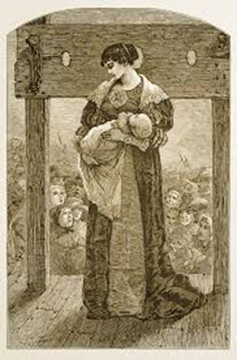
2. The meteor

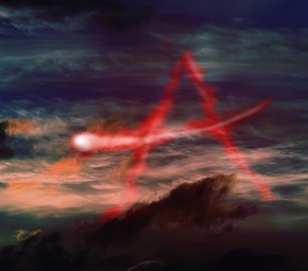
Meaning of the Symbols and Image Representation
The Pearl
The first image represents a symbol of the pearl and her mother Hester. With the name "Pearl" you will get to think of precious jewels, and there is indeed something very regal about Pearl. Pearl is a symbol of all that Hester gave up after she committed adultery and gave up her place in puritan society. Although pearl has been establishing as a very complex and significant character, she has been primarily been used as a symbol. Hester has gone through hell and high water as a result of giving birth to pearl. She has been present as a sort of living version of her mother’s scarlet. Pearl is a true physical consequence of sexual sin. Pearl plays a two side role of acting as a punishment to her mother and also is a great source of blessing to her mother too. Moreover, pearl's living gives her mother a great inspiration and always gives her a wide hope to live.
"Come along, Pearl!" said she, drawing her away, "Come and look into this fair garden. It may be, we shall see flowers there; more beautiful ones than we find in the woods." This quote reveals the love and concern of Hester as she takes Pearl to a flower garden.
The Meteor
The second image represents a symbol of a meteor I the shape of an A. for such meteors with such shapes the community leaders were expected to interpret this explosion to be the message from God. The actual witness of the meteor image in the sky are Dimmesdale, Hester, and Pearl who had stood in the scaffold. To Dimmesdale, the meteor implies that he was to wear a mark of shame as Hester does. He thus ends up to thinks solely about what the meteor means to him and him alone. Consequently, the meteor is interpreted differently by the rest of the community which for them they think it stands for an 'Angel'. The Puritans commonly looked to symbols to confirm divine sentiments. In this narrative, however, symbols are taken to mean what the beholder wants them to mean. The incident with the meteor highlights and exemplifies two different uses of symbols: Puritan and literary.
Conclusion
In conclusion, the use of the two symbols has been impactful to the book thus very significant. They also allow people to go beyond what is known or seen by creating linkages between very different concepts and experiences.

References
Hawthorne, N. (1998). The scarlet letter. Oxford University Press, USA.

